**Building and Packaging dotnet**

* .net framework versions:
  + .net 2,3,4 (Windows)
  + .net 5 +
    - .net core
    - aspnet core
* Build the no commerce <https://github.com/nopSolutions/nopCommerce>
* Software’s:
  + .net core 7 <https://learn.microsoft.com/en-us/dotnet/core/install/linux-ubuntu-2204>

sudo apt-get update && \

sudo apt-get install -y dotnet-sdk-7.0

Build steps:

git clone https://github.com/nopSolutions/nopCommerce.git

cd nopCommerce

git checkout master

dotnet restore src/NopCommerce.sln

dotnet build src/NopCommerce.sln

**Azure DevOps** [Formally known as VSTS]

Azure DevOps offers services to manage whole project

* + Project Management
    - Planning
      * Agile Boards
      * Issue Tracker
    - Execution
      * Wiki Pages
      * Test Management
  + DevOps:
    - VCS:
      * Azure Source Repos
        + Git
        + TFVC
    - Pipelines:
      * Build Pipelines
      * Release Pipelines
    - Artifacts
* Azure DevOps can be used by two ways
  + Self-Hosted <https://learn.microsoft.com/en-us/azure/devops/server/download/azuredevopsserver?view=azure-devops>
  + Cloud Hosted: <https://azure.microsoft.com/en-in/products/devops>
* Azure DevOps Services: Cloud Hosted Version of Azure DevOps
  + Pricing: <https://azure.microsoft.com/en-in/pricing/details/devops/azure-devops-services/>

Create a free azure Devops account <https://azure.microsoft.com/en-in/products/devops>   
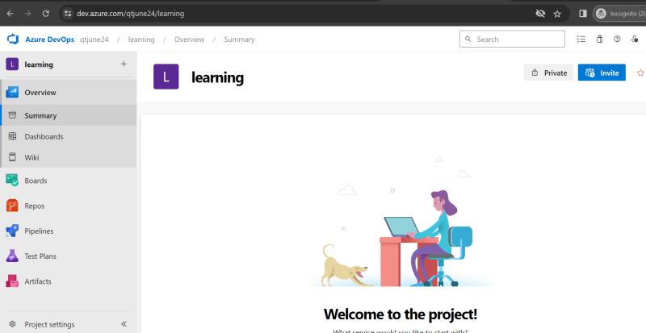

**Importing an Existing git repo into Azure DevOps**

Import Repository from github into your account  
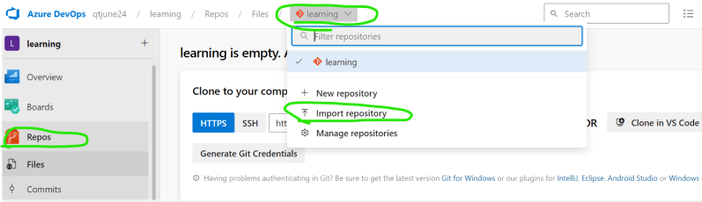  
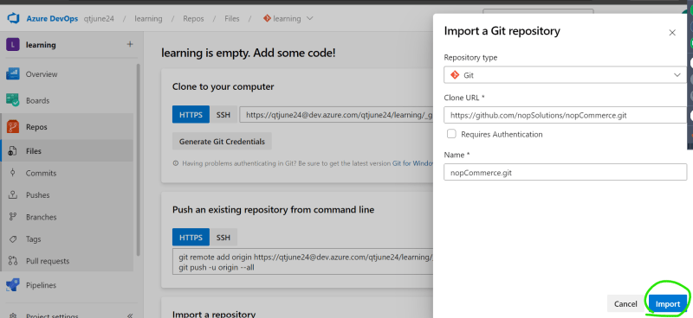

Now let’s setup build i.e. CI pipeline  
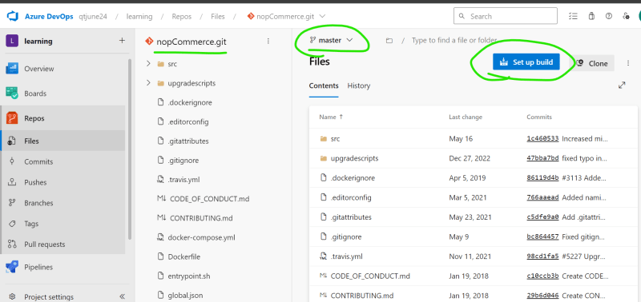  
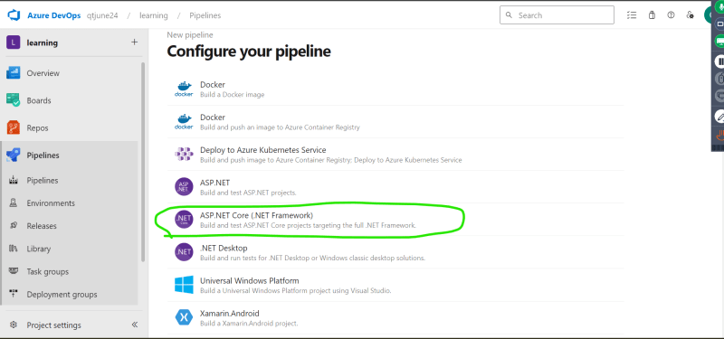  
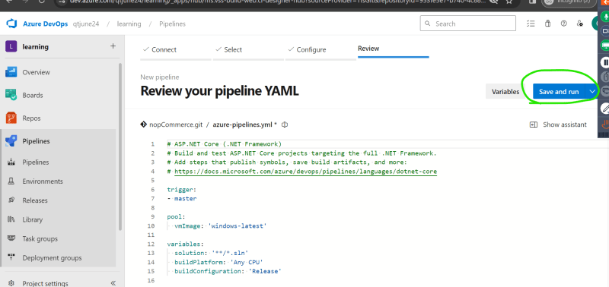  
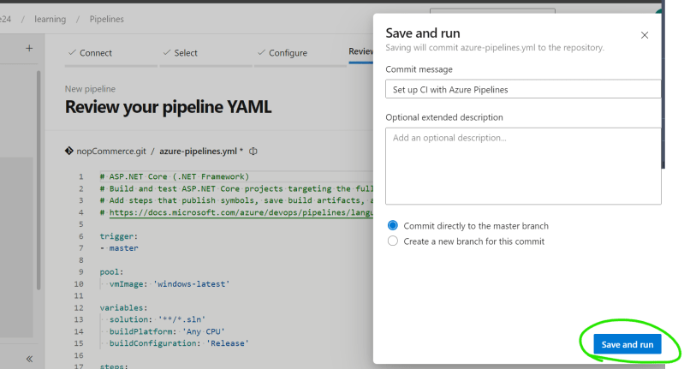  
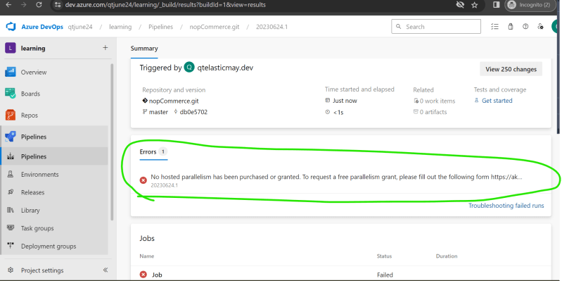

By default, Parallelism request is disabled we need to enable this by sending request to microsoft on this location <https://aka.ms/azpipelines-parallelism-request>